Cabo Verde

## Freedom House political status

The data set shows the Freedom House political scores and status of the country each year.

## # A tibble: 19 x 5  
## country iso3c date mean status  
## <chr> <chr> <dbl> <dbl> <chr>   
## 1 Cabo Verde CPV 1996 1.5 Free   
## 2 Cabo Verde CPV 1998 1.5 Free   
## 3 Cabo Verde CPV 2000 1.5 Free   
## 4 Cabo Verde CPV 2002 1.5 Free   
## 5 Cabo Verde CPV 2003 1 Free   
## 6 Cabo Verde CPV 2004 1 Free   
## 7 Cabo Verde CPV 2005 1 Free   
## 8 Cabo Verde CPV 2006 1 Free   
## 9 Cabo Verde CPV 2007 1 Free   
## 10 Cabo Verde CPV 2008 1 Free   
## 11 Cabo Verde CPV 2009 1 Free   
## 12 Cabo Verde CPV 2010 1 Free   
## 13 Cabo Verde CPV 2011 1 Free   
## 14 Cabo Verde CPV 2012 1 Free   
## 15 Cabo Verde CPV 2013 1 Free   
## 16 Cabo Verde CPV 2014 1 Free   
## 17 Cabo Verde CPV 2015 1 Free   
## 18 Cabo Verde CPV 2016 1 Free   
## 19 Cabo Verde CPV 2017 1 Free

## Freedom House classification of political change

The data set shows the GDP growth and the ecomic growth classification of the country each year.

## # A tibble: 19 x 4  
## country iso3c date politicalChangeFH  
## <chr> <chr> <dbl> <chr>   
## 1 Cabo Verde CPV 1996 no change   
## 2 Cabo Verde CPV 1998 no change   
## 3 Cabo Verde CPV 2000 no change   
## 4 Cabo Verde CPV 2002 no change   
## 5 Cabo Verde CPV 2003 democratization   
## 6 Cabo Verde CPV 2004 no change   
## 7 Cabo Verde CPV 2005 no change   
## 8 Cabo Verde CPV 2006 no change   
## 9 Cabo Verde CPV 2007 no change   
## 10 Cabo Verde CPV 2008 no change   
## 11 Cabo Verde CPV 2009 no change   
## 12 Cabo Verde CPV 2010 no change   
## 13 Cabo Verde CPV 2011 no change   
## 14 Cabo Verde CPV 2012 no change   
## 15 Cabo Verde CPV 2013 no change   
## 16 Cabo Verde CPV 2014 no change   
## 17 Cabo Verde CPV 2015 no change   
## 18 Cabo Verde CPV 2016 no change   
## 19 Cabo Verde CPV 2017 no change

## Freedom House score trend

The plot shows the Freedom House scores trend of the country.

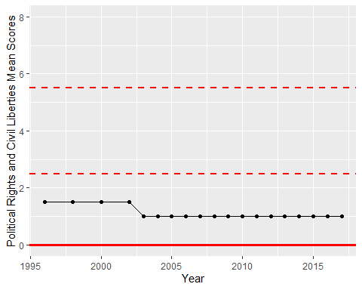

Freedom House Score Trend